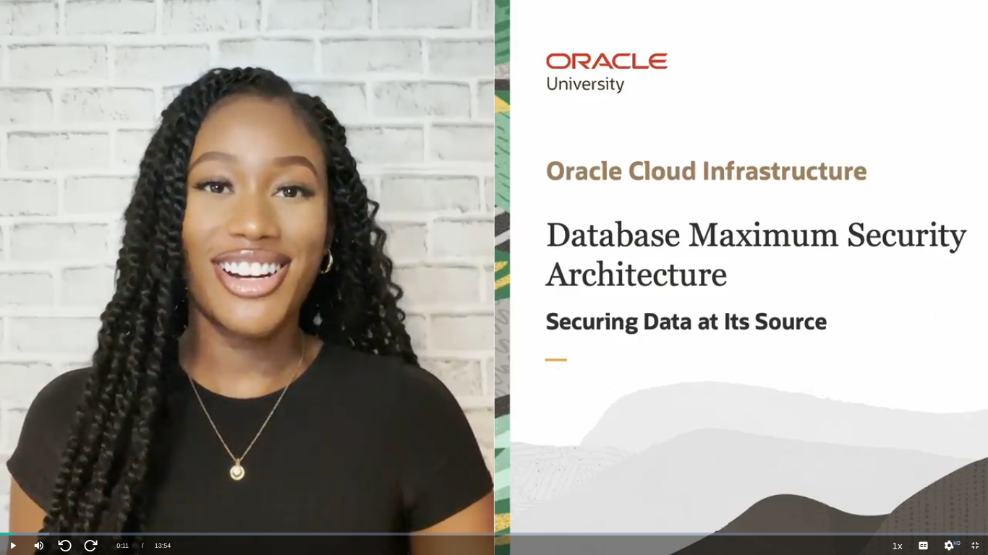

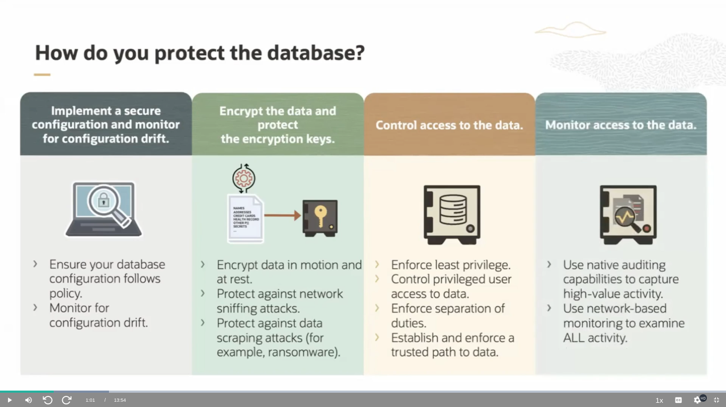

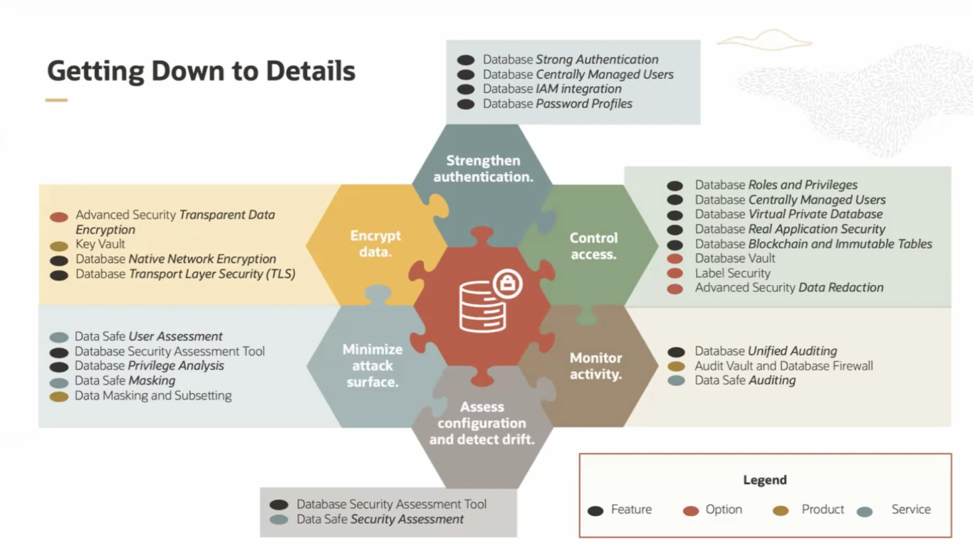

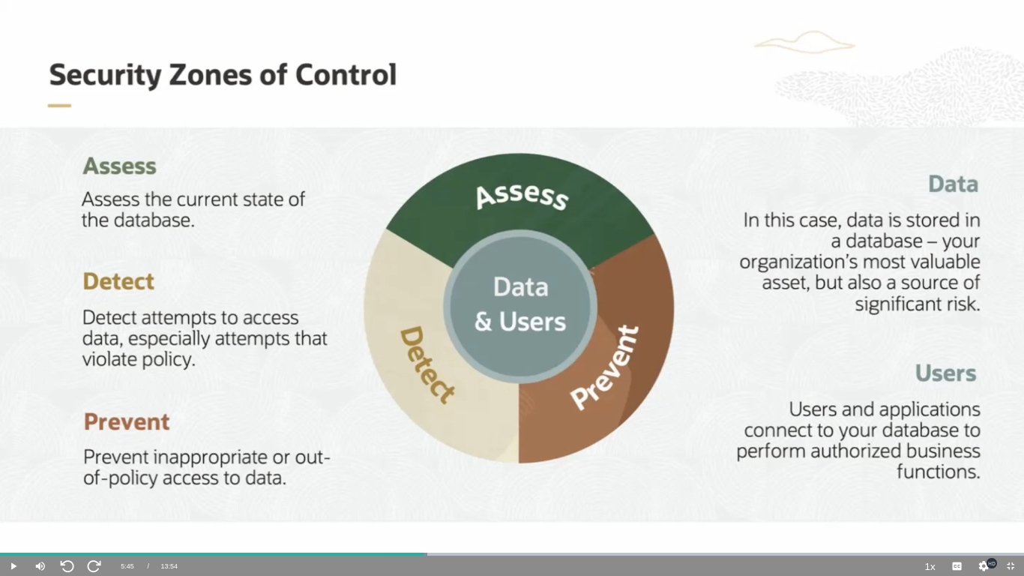

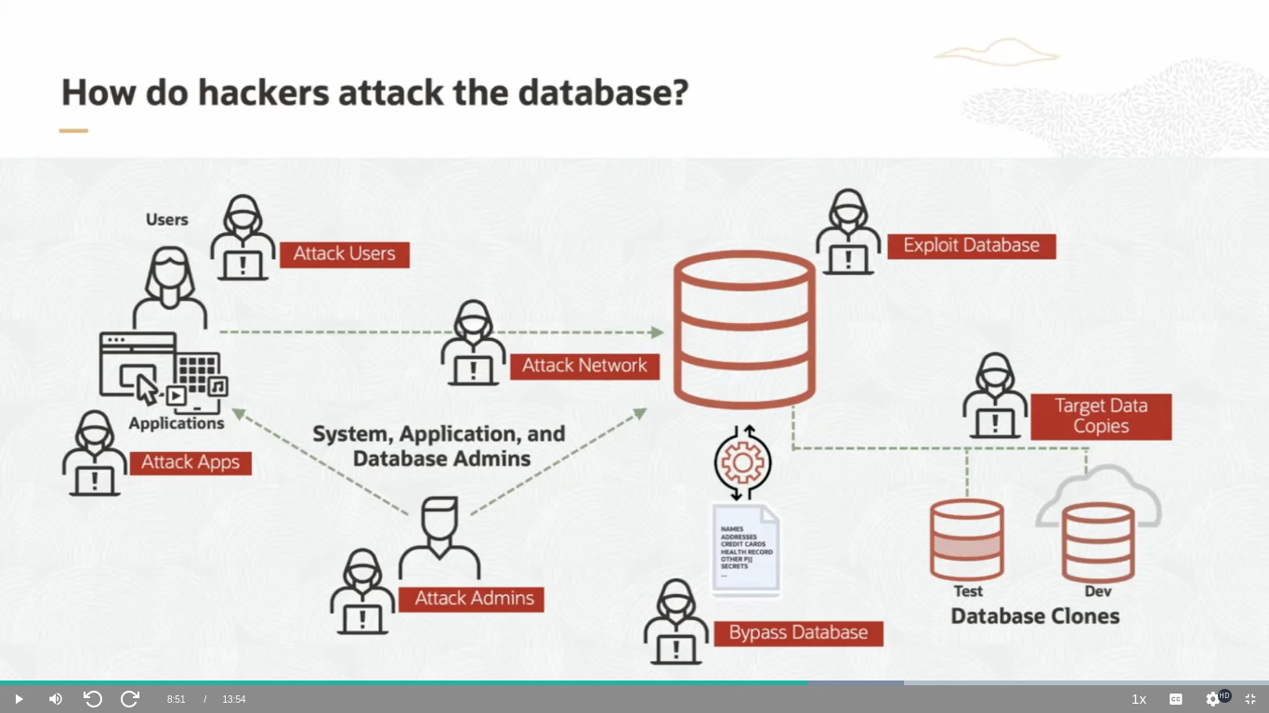

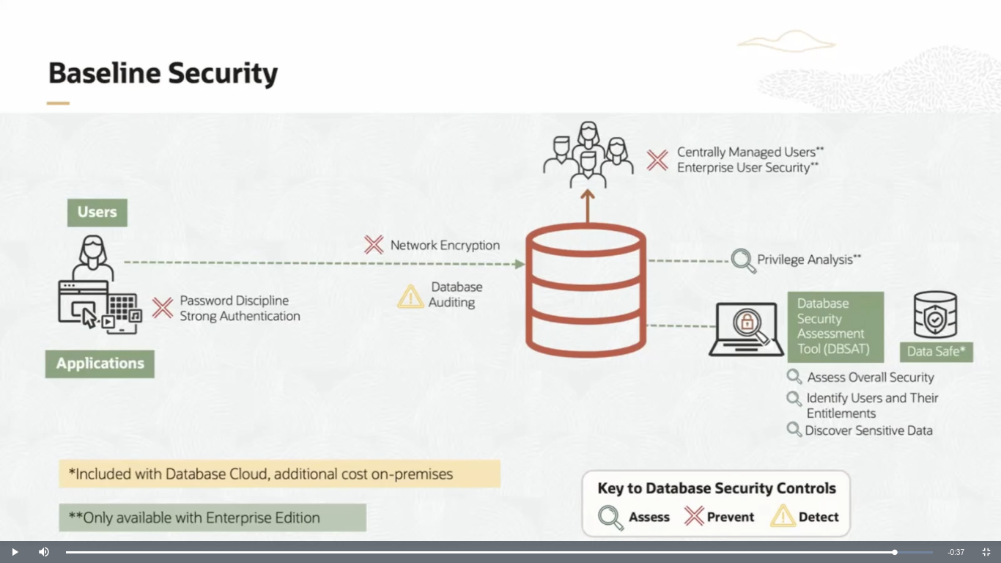

[AUDIO LOGO]
In this lesson, we are going to be talking about Oracle's maximum security architecture. My name is Kamryn. Let's get started. Securing the Oracle database is much like securing any IT system. It starts with implementing a secure configuration and monitoring that configuration for drift. As part of that, you will want to validate your configuration against best practices and generally accepted security templates, like the CIS benchmarks or DISA STIG.
Next, you need to encrypt your data and protect the encryption keys. Encryption is a fundamental security control, and without it, your data will always be exposed to at least one attack vector. Encryption should be for data at rest and in motion. Then, you want to control access to your data, ensuring that database accounts have only the privileges necessary to perform their business function. This includes removing unnecessary privileges from interactive accounts, controlling your privileged users, and enforcing a trusted path to data that considers session context as well as assigned privileges.
Remember that most database breaches involve the use of compromised accounts. So this step is very important. You also need to plan for failure, monitor access to the data so that if one of your other controls fails, you have the data you need to hopefully identify out of policy activity quickly and support your post-breach investigations. This includes a combination of native database auditing. The Oracle database has best-in-class capabilities to help in this area and network-based activity monitoring that examines all incoming SQL statements.
No single product or option fully secures your database. It takes a combination of several technologies working together. Assess your system to identify insecure configuration choices, configuration drift, and missing security patches. Minimize your attack surface by removing excessive or unused privileges, sensitive data from test, and development systems. Encrypt your data at rest and in motion.
For data at rest, you also need to protect your encryption keys from loss or theft. Strengthen authentication to the maximum degree possible, preferably employing multi-factor or strong authentication for interactive accounts. Control access to data and enforce separation of duties. And, again, plan for failure. Monitor database activity to detect anomalies and support investigations. You can't skip any of these areas. Leave out just one piece of the puzzle, and there is an easy path to your data for attackers to exploit.
From a database feature, option, product standpoint, here is what goes into each of those areas. Note that a good baseline level of security can be achieved by properly configuring included database features. Also, note that most of our Database Cloud Services include all database options and the Data Safe security service at no additional cost. Securing an Oracle database is much like securing any other system. You are protecting your data. That could be intellectual property, financial data, personal data about your customers or staff, or more likely, a combination of all three.
Because data is valuable, you need to Guard against theft and misuse. This data is used for business purposes, and that means users and applications connect to the database, and you need to safeguard that data with security controls that restrict access to the data according to your policy. To do this, you'll need to do three things-- assess the system to determine its current state and develop a remediation plan. Is the system configured properly? Patch is applied regularly? How are user privileges managed? Are you enforcing least privilege? What types and how much of sensitive data is the system holding?
Your existing investment in the Oracle database gives you the features and utilities you need to assess your database and identify areas for improvement and risk reduction. To detect, detect attempts to access data outside of policy and identify anomalies in data access. Almost all database activity is repetitive. So anomalies are frequently a leading edge indicator of attempted data theft.
Prevent access to data that doesn't go through the database control mechanisms, sniffing traffic over the network, reading the underlying data storage layer or misuse of database exports and backups. Block inappropriate access to data through control mechanisms that consider the context of the access, not just the identity of the account accessing the data. Oracle provides industry-leading capabilities for each of these security control objectives. Our team can help you identify the right technical enforcement for virtually any control objectives.
How are databases attacked? Databases are valuable repositories of sensitive information, and a data thief is almost always going to target databases in an attempt to steal data. Before we think about defending against this type of attack, let's look at how the attacks normally occur. Databases don't just operate in a vacuum. A database is accessed by users and applications. In most cases, there are copies of databases for test, development, and stage and user acceptance testing.
Databases persist data into a storage medium and run on servers with operating systems and peripherals. All of these are managed by administrators. And administrators are a hacker's favorite point of attack. If they can compromise an administrator account, they're in with elevated privileges and, in many cases, no controls over what they can do.
If the attackers can't compromise an administrator account, they can often compromise an end user account, lower privileges, but often still with access to data. Or, it can be used as a stepping stone to get to that access. Applications also make an attractive target. They are frequently more exposed than the database or database server, often even available from outside the corporate firewall. Speaking of those firewalls, if an attacker has managed to penetrate to the internal network, they may choose to go after data traveling over that network. This type of attack is much less likely to be detected than attempts to access the database directly.
Another popular attack is against the underlying data files, database backups, or database exports. Here, again, if the attacker is successful, they may be able to steal the entire database without ever having to try to log into it. If none of those things work, perhaps the database has an unpatched vulnerability. In many cases, there are automated attack toolkits that help exploit those vulnerabilities.
And don't forget those non-production copies of the database. In many systems, the test and development instances are just clones of production and almost never are they monitored as closely as production. There are some things we always expect to be done, what we call the baseline security posture. Establishing the baseline security posture involves several different types of controls. We will assess the system state, prevent unauthorized activity and detect activity that is relevant to our security controls.
Our first control is assessing the database configuration. We want to ensure we haven't made configuration decisions that introduce unnecessary risk into the environment. We'll also check to make sure that the database is current on security patches. For this, we have two tools available to us, Database Security Assessment Tool and Data Safe. Database Security Assessment Tool is a free utility available for download via My Oracle Support.
Data Safe is a cloud service that is included at no additional cost with Oracle Cloud database services. Data Safe is also available for on-premises databases, but there is an additional cost for those. Users and applications connect to the database. We want to ensure that if they're connecting with the username and password, we're practicing good password discipline. We also want to consider the use of strong authentication. Your Oracle database supports Kerberos, PKI certificate, and multi-factor authentication.
We'll want to make sure those users are really able to connect to the database identifying dormant accounts and checking to be sure we haven't granted privileges that don't make sense in our environment. Here, again, Database Security Assessment Tool and Data Safe help by pointing out use of things, like the SELECT ANY TABLE privilege or grants of the DBA roles.
We should also check that database accounts are actually using the privileges we granted. Privilege analysis monitors, privilege usage and can report on privileges that an account has that are not used. We can then remove those unnecessary privileges, reducing the attack surface presented by those users. Note that privilege analysis is only available for Oracle Enterprise Edition database. It is not present in Oracle Standard Edition database. Users are inserting and updating data and also retrieving data.
That data is traveling over the network. And in most cases, we'll want to encrypt the data to reduce the chances that an attacker can simply sniff the network to steal data. The Oracle database supports two different types of network encryption, native network encryption and industry standard certificate-based TLS. Depending on how many users connect to our database and how many databases we have, we may want to implement centralized authentication.
Your Oracle database supports two types of centralized user management. One feature, enterprise user security, is available on all currently supported database versions and allows the Oracle database to consult an Oracle LDAP directory for users and role membership. The other feature, centrally manage users, was new in Oracle 18c and allows the Oracle database to connect to Microsoft Active Directory for users and role membership. We need to know what those users are doing. And for this we use Database auditing.
The Oracle database offers a comprehensive auditing capability, and you will usually want to audit database connections, especially failed logins, data control language, including creation of users and privileged grants. In data definition language like creation of stored procedures, database links, et cetera, all of these are fairly rare in most databases. So this level of auditing presents minimal performance impact. Finally, we'll want to make sure that we know what sensitive data resides in the database.
Is the baseline security posture appropriate for the level of risk presented by the data, or should we do more to protect our data? Here, we return to DBSAT or Data Safe, which allow us to scan the database for sensitive data, reporting on what types of data are found and how much of it there is. All of the controls we've talked about so far are baseline. These are the things we think any database should do. And everything we've discussed so far can be done without the need for additional costs, products, or options.

